Geophysical and Geoarchaeological Surveys at the Wormsloe Plantation, Fall of 2008

A Report
By
Jessica Cook Hale
Wormsloe Fellow
The University of Georgia
Athens, GA 30602
Table of Contents
Introduction 3
Introduction 3
Methods 9
GPR 11
EM 11
Electrolysis 12
Soil Probing and Pedestrian Survey 13
Results 15
GPR 15
EM 17
Soil Probing and Pedestrian Survey 18
Electrolysis 19
Discussion 20
Historical documentation 20
Conclusions 25
References 26

Index of Figures

Figure 1: Map of Wormsloe showing survey area 5
Figure 2: 1897 map showing structural improvements to Wormsloe 6
Figure 3: Section B of 1897 map showing the survey area in relation to the main house 7
Figure 4: Close-up of survey area showing three buildings 7
Figure 5: Correlation of geophysical data with 19th century map 8
Figure 6: GPR results, ~ 0.25 meters depth 15
Figure 7: GPR results, ~ 0.5 meter depth 16
Figure 8: Master Grid EM data 17
Figure 9: subsurface disturbance map, 485 N to 495 N, 500 E to 530 E 18
Figure 10: Rice Mill at Wormsloe 24

Index of Tables

Table 1: Complete list of Structures built during the 19th century at Wormsloe 20
Table 2: Modified list of possible structures within survey area 22

Introduction
In spring of 2008 Ground Penetrating Radar (GPR), Electromagnetic/Conductivity (EM), and Magnetometry/Gradiometry (MAG) were all performed within a survey area located south of the main house at Wormsloe Plantation (figure 1). These geophysical prospection technologies revealed subsurface anomalies that were later shown during excavations undertaken in April of 2008 to be remains of 19th century structures. Correlation with 19th century maps suggested that during the 19th century, at least three structures stood within the survey area and that these structures were related to economic activities at the Wormsloe Plantation (figures 2 - 5).

Accordingly, further surveys were proposed and carried out in fall of 2008 in order to elucidate the nature of these features. GPR and EM were again employed but due to equipment problems, the MAG was not. However, additional geoarchaeological methods such as pedestrian survey and ground probing were added in order to supplement the geophysical data. The area being surveyed was expanded, and the grid coordinate stakes that mark the grid corners were refined in accuracy and precision by using a Total Station system (EDM). Global Position System (GPS) coordinates were also taken at all of the grid corner stakes by personnel from the Center for Remote Sensing and Mapping Science (CRMS) at the University of Georgia. The goal of this more intensive survey was to refine the geophysical and geoarchaeological datasets in order to correlate them with historical and ecological data.

Geophysical prospection is the ideal method for mapping potential archaeological sites and features such as those that are found at Wormsloe. These methods are by definition not invasive techniques, and can be their very nature cover substantially larger areas of the Plantation than traditional excavation and soil sampling methods (Kvamme, 2003). Further, the data are easily rendered in digital formats that can be correlated well with the other Geographic Information Systems (GIS) mapping activities by CRMS. This is part of a larger effort to establish baseline data for the entirety of the Wormsloe plantation in order to properly catalog its historical, ecological, geographical, and archaeological assets for further long term study. In short, geophysical prospection and minimally invasive geoarchaeological methods have been chosen for this study because they offer the best methods to gather the most data with the least impact on the overall site. In its use of leading technologies as well as in its holistic approach, the Wormsloe Plantation geophysical and geoarchaeological surveys are a definitive example of the flexibility and comprehensive nature of this type of prospection possible with 21st century technology.

The results of the surveys done throughout fall of 2008 are here presented along with a synthesis between these results and historical data organized by Drew Swanson, Wormsloe Fellow in Environmental History. Possible interpretations of the geophysical anomalies will be proposed based on these data. The effectiveness of these methods for this individual survey area will be assessed and the next stage in survey at the Wormsloe Plantation will be discussed.

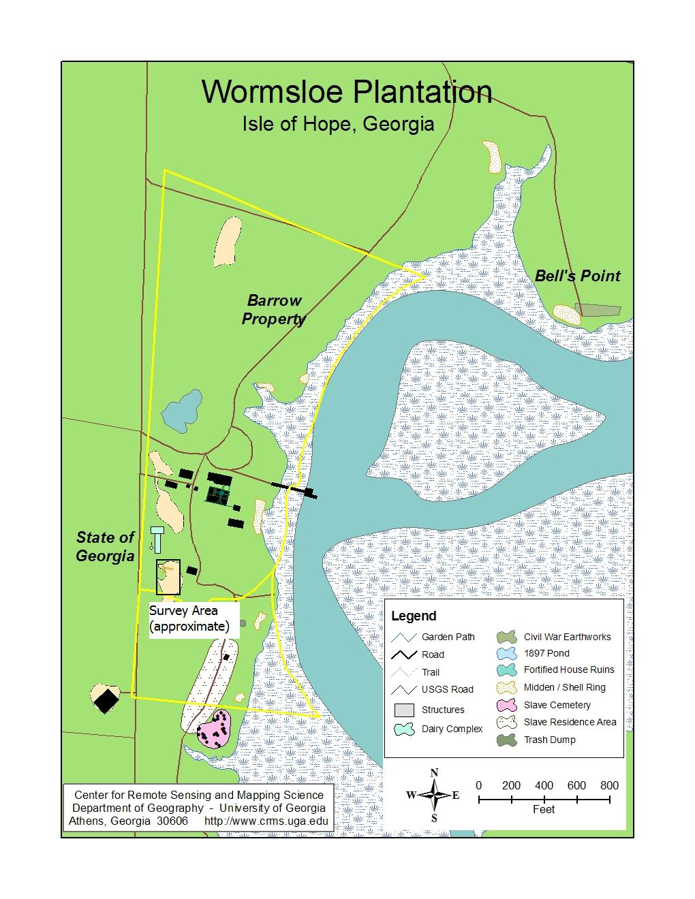
Figure 1: Map of Wormsloe showing survey area
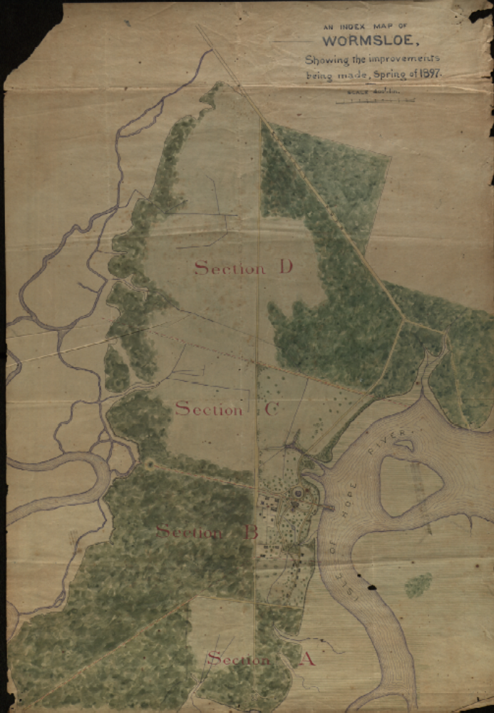
Figure 2: 1897 map showing structural improvements to Wormsloe

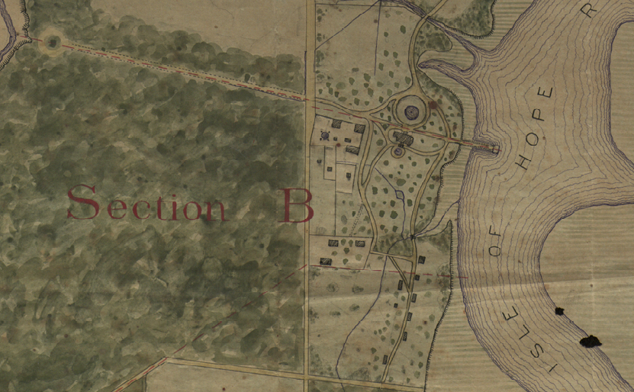
Figure 3: Section B of 1897 map showing the survey area in relation to the main house

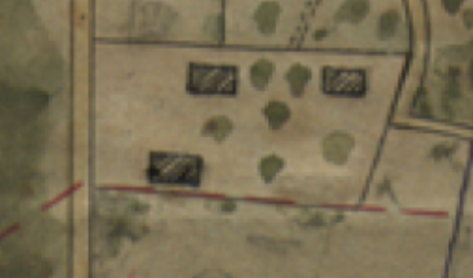
Figure 4: Close-up of survey area showing three buildings

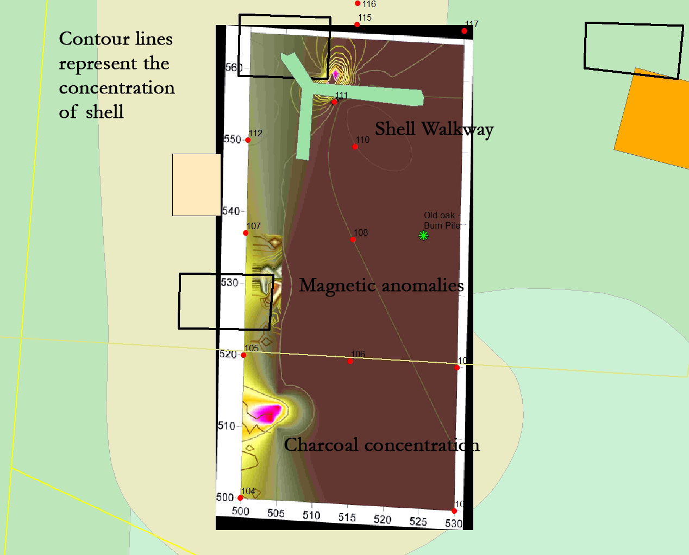
Figure 5: Correlation of geophysical data with 19th century map

Methods

During the fall months of 2008, intensive geophysical and geoarchaeological surveys, in addition to completion of a field lab, were carried out at the Wormsloe Plantation. The surveys were conducted within the area previously explored in the spring of 2008. During the earlier spring surveys, the area was divided into grids for survey using a compass and measuring tapes. This was done because the Electronic Distance Measurement device (EDM) was undergoing repair at the University of Georgia. In August of 2008, the EDM was fully functional and available, so the survey area was remapped and the survey stakes placed during the spring were corrected to more accurate, precise angles and distances. This was done to more accurately tie in the survey grids with GIS work by CRMS.

The first round of the August work at Wormsloe was carried out on August 18^{th,} with a focus on final organization of the new field lab at Wormsloe, but had to be cut short due to the approach of Tropical Storm Fay. Accordingly, the first phase of the geophysical surveys was completed from August 25th to August 27th. During this round of survey, new points on the grid were measured, and a new GPR survey was performed using a 900 MHz antenna.

In September of 2008, archaeological work at the Wormsloe Plantation focused on the conservation of metal artifacts recovered during excavations in April 2008, and the continuation of geophysical prospection methods. The metal artifacts were predominantly iron though there were three copper alloy artifacts recovered as well. All showed signs of considerable weathering; the iron artifacts were all heavily oxidized, and the copper alloy items showed a green “patina” that also indicates oxidation. This is of course not a surprising state in which to find metal artifacts, but their condition calls for stabilization and conservation.

In addition to metal conservation, a new electromagnetic (EM) survey was done in September of 2008. This was done in order to expand the current geophysical dataset beyond Ground Penetrating Radar (GPR) and magnetometer (MAG). A previous EM survey in March of 2008 was not productive, yielding data with copious interference or “noise”. It was hoped that a new survey would not be subject to the same problems.

Ground probing was used in order to explore better the anomaly revealed in the southernmost portion of the GPR grid surveyed in August 2008. GPR and EM rely upon the electromagnetic properties of materials to indicate changes in the subsurface. While they can clearly pinpoint changes in subsurface layers, they can not specify from what exact materials those changes result. Limited ground probing is a useful way to determine the difference between a subsurface anomalies caused by an accumulation of bricks versus an anomaly caused by a collection of metal debris.

The focus of the fieldwork during October and November of 2008 was on completion of the geophysical dataset. Specifically, the remainder of the current survey site required that more GPR and EM data be gathered, processed, and interpreted. Accordingly, fieldwork during early November set out to “fill in the gaps” so to speak, within the survey site. Also, additional methods for collating these data with the GIS database under construction at CRMS. In addition to GPR and EM, a limited soil probing survey was again performed.

Finally, as a capstone to the archaeological survey work, a list of structures compiled by Drew Swanson, Wormsloe Fellow in Environmental History, was reviewed in order to look for possible correlations to the GIS and geophysical data. It is hoped that his interpretation of the Wormsloe papers into cogent history will assist in comparing these three data sets to one another.

GPR
The GPR unit was a GSSI SIR-2000 using a 900 MHz antenna. All of the instrument parameters were set by hand in the field, as before. The data were collected on a spacing of 0.5 meter transects. No survey wheel or user marks were used in the data; instead, navigation was provided using artificial marks entered by the processing software later. A 900 MHz antenna was chosen because it renders higher resolution data for shallow depths. This antenna was used for all GPR surveys performed during fall of 2008. The historic component of this site is typically less than 0.5 m. in depth, and so this shallow depth can be rendered by a 900 MHz antenna, and is more appropriate than the 500 MHz antenna configuration deployed in the previous surveys of spring 2008. The GPR survey was done on a grid expanded from the one surveyed in the spring, as well. For inter-comparison, the same coordinate system was retained.

After the data were collected, they were processed using GPR_SLICE, Oasis MONTAJ, and Golden Software SURFER 8. Initial processing was done in GPR_SLICE, and additional filtering was performed in MONTAJ and SURFER. In addition to rendering standard plan view maps, 3D images were also created in MONTAJ and SURFER in order to better highlight the GPR anomalies. It is important to note that the word anomaly is used here because absent actual ground-truthing of the data, one can not say with any certainty what the data actually represent. However, patterns within anomalies can be obvious to the trained eye, allowing for spatial analysis as well as more accurate placement of geological coring and archaeological excavation units.

EM
Electromagnetic Induction (EM survey) works by inducing and then measuring weak electromagnetic currents in the ground. The ability of the subsurface materials to conduct electricity can then be measured. The presence of archaeological features composed of any material different from the surrounding soil can then be detected. EM surveys can also measure multiple frequencies; these correspond to different depths. Lower frequencies can not reveal great detail, but are able to penetrate deeper into the ground due to their longer wavelengths. Higher frequencies may be able to resolve finer details in the data, but are unable to penetrate as deeply into the ground. The depth to which an individual frequency can penetrate is known as “skin depth”, and this can be calculated using the frequency and the estimated resistivity of the soil. Using a range of frequencies, as has been done here, can be used to explore different depths from immediately below the subsurface down to geological, and not merely archaeological, features. In this study, 6 frequencies were used, ranging from 330 Hz to 19950 Hz.

EM data were downloaded from the GEM300 instrument used during the survey and processed using SURFER and MONTAJ. Each of the six frequencies was used to provide information about anomalies at different depths. Depths were roughly calculated using the formula for skin depth (rendered as 503√ρ/_{r}μf, where ρ is the resistivity of the soil, _{r}μ is usually assumed to be 1 and f is frequency) (Milsom, 1996) but more accurate correlation for depth was generally found by cross-comparing EM data plots with GPR data. This is due to the presence of lateral and vertical heterogeneity in the subsurface: simply put, the variability of materials in the subsurface causes the skin depth to change. Comparison with GPR data and the skin depth calculations do get one within an acceptable range, however.

Electrolysis
The first step in conserving metal artifacts is simply put, to clean them up. Rust and patina must be removed before the metal can be preserved. Electrolysis was the preferred method chosen for this due to its relative ease of use and nondestructive nature. It is a relatively simple and inexpensive method as well. All that is required is a bath with the appropriate solution and a source for electricity.

Understanding the way in which electrolysis work requires only a basic review in chemistry. Electrons orbit the nucleus of an atom within orbital shells. Each orbital shell has a set number of electrons that it requires in order to be balanced in their electrical charge (Known as the Pauli Principle). When an element doesn’t have enough electrons to fill its highest orbital shell, it will bond with another element that has the right number of electrons in its highest orbital shell; these electrons are shared between the two elements.

Metals such as iron and copper, and oxygen have an affinity for one another due to this phenomenon. Therefore, when iron or copper are exposed to oxygen for any length of time, they tend to bond with it, creating rust or patina. Electrolysis works by reversing the process of oxidation; this is called reduction.

When an electrical current is passed through a solution containing cations (which are by definition already positively charged and eager to attract more electrons, thereby facilitating the conduction of the electrical current), the negative anode gives up electrons. These free electrons bond with the oxygen within the rust or patina, and essentially carry them away towards the cathode. When the oxygen reaches the cathode and the charge leaves the system, the oxygen then bonds with the cathode, creating rust or patina on the cathode instead of the anode and/or artifacts attached to the anode.

For this project, a 6/12 ampere battery charger, a sodium bicarbonate solution to provide cations, and copper pipe were used. The metal artifacts were attached to the copper wire using alligator clips. The copper wire was attached to the negative pole of the battery charger and lowered into the solution. The positive pole of the battery charger was then attached to a so-called “sacrificial” cathode, also a copper pipe. This was also lowered into the solution and the charger was run at the 12 amp setting.

Soil Probing and Pedestrian Survey
Additionally, soil probing and pedestrian survey were performed in selected areas of the site. Soil probing focused on the area south of the burn pile. A short (<1 meter long) probe was pushed into the ground, and the density of the subsurface was estimated using a qualitative scale of 1 to 10: 1 indicated no obstructions at all within a sandy, soft soil typical of the Georgia coastal plain, and 10 represented the complete inability to push the probe through the subsurface below the grass due to solid brick, concrete, or other hard materials left over from anthropogenic activities. Pedestrian survey also focused on this area and some areas slightly south and east of the mapped grids, on the edge of the clearing. When an area of interest was found, its coordinates were noted along with details related to the find. These kinds of information can assist in geophysical methods by providing surface clues to the location of subsurface features.

Results

GPR
Two different depths were most useful for the interpretation of GPR results: time slices 5 and 10 (figures 6 and 7). Time slice 5 is approximately 0.25 in depth, and time slice 10 is approximately 0.9 to 1.0 meter in depth. Excavations in spring of 2008 demonstrated quite clearly that this site is very shallow, so both of these time slices are well within the parameters within which we can expect to see anomalies related to 19th century activities.

In time slice 5, the GPR results for the depth of approximately 0.25 meters show strong anomalies in the area south of the burn pile (figure 6). These are roughly rectilinear in nature, a strong indication that they are the remains of anthropogenic activities. Nature generally doesn’t leave behind straight lines in the subsurface, and these become especially clear in coastal plain sandy soils.
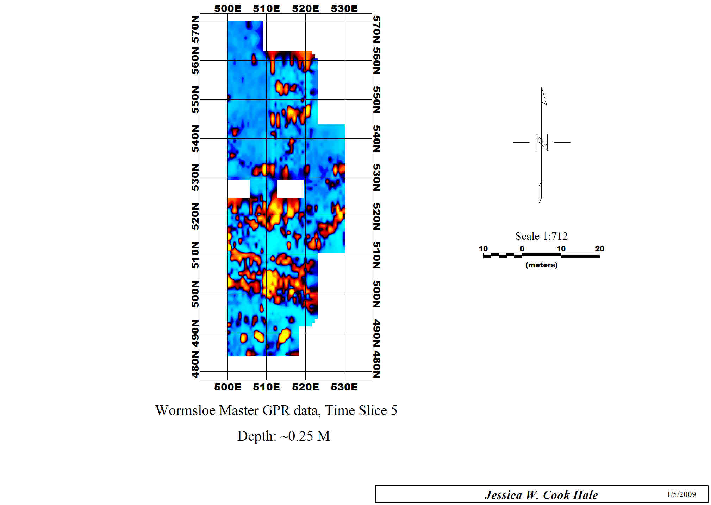
Figure 6: GPR results, ~ 0.25 meters depth
GPR data from time slice 10, at approximately 0.5 meter in depth, also shows linear anomalies (figure 7). These are more analogous to the anomalies revealed in the initial survey in spring 2008, and are likely related to the structural remains partially uncovered during the limited excavation at that time. One linear anomaly, located at approximately 510 N, 510 E, was expressly chosen for excavation in spring of 2008 but did not reveal any concrete structural remains; for the present time, its precise nature is not known. Steve Harn, caretaker of the property, recalls oral communications to him from his uncle, former plantation caretaker, indicating that trash was dumped into pits in this field area, probably around circa 1950 or thereabouts. This raises the possibility that at least some of these anomalies may be related to dumping activities, and are not necessarily structural remains.

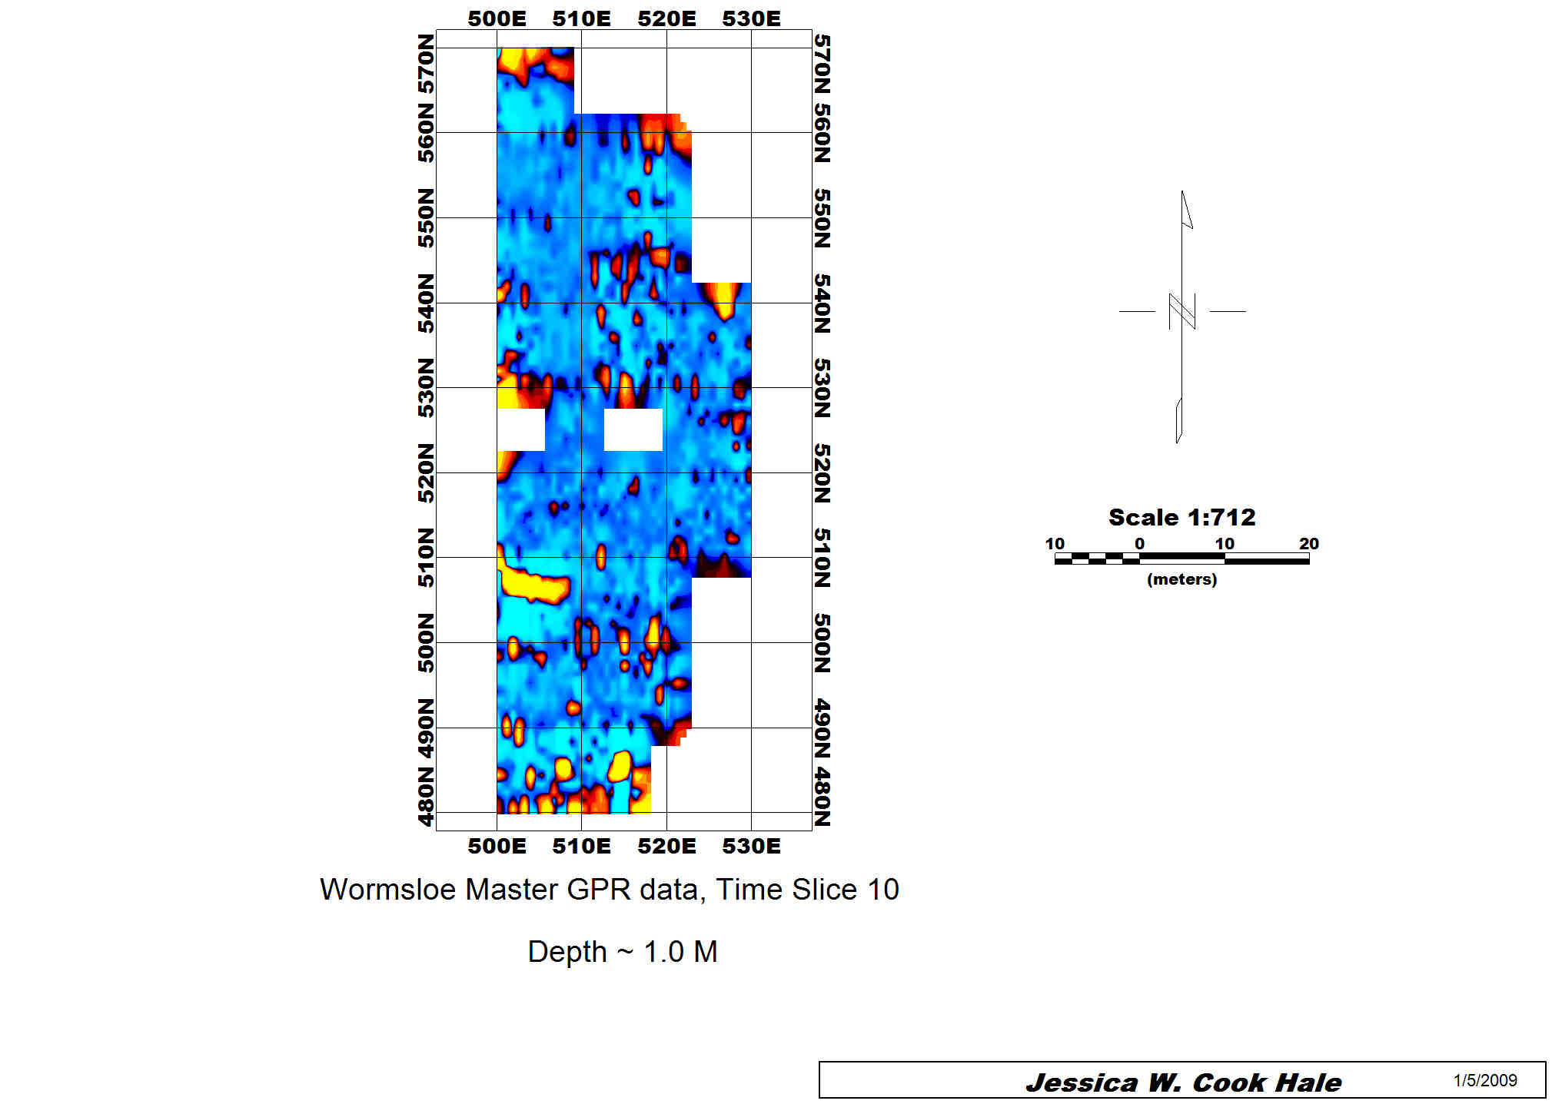

Figure 7: GPR results, ~ 0.5 meter depth

EM
Conductivity data results from 3870 MHz were most useful for interpretation (figure 8). Using the equation for calculation of skin depth (Milsom, 1996), these data are located at approximately 0.8 meter in depth, and show a cluster of anomalies south of the burn pile that correlate well to the GPR anomalies seen in time slice 5. These anomalies are also roughly rectilinear in nature. The orientation of these anomalies appears to be along an east to west axis. Additional anomalies also appear in the most southern portion of the grid. The overall shape is roughly rectilinear, albeit not as definitively as the larger anomaly directly south of the burn pile.
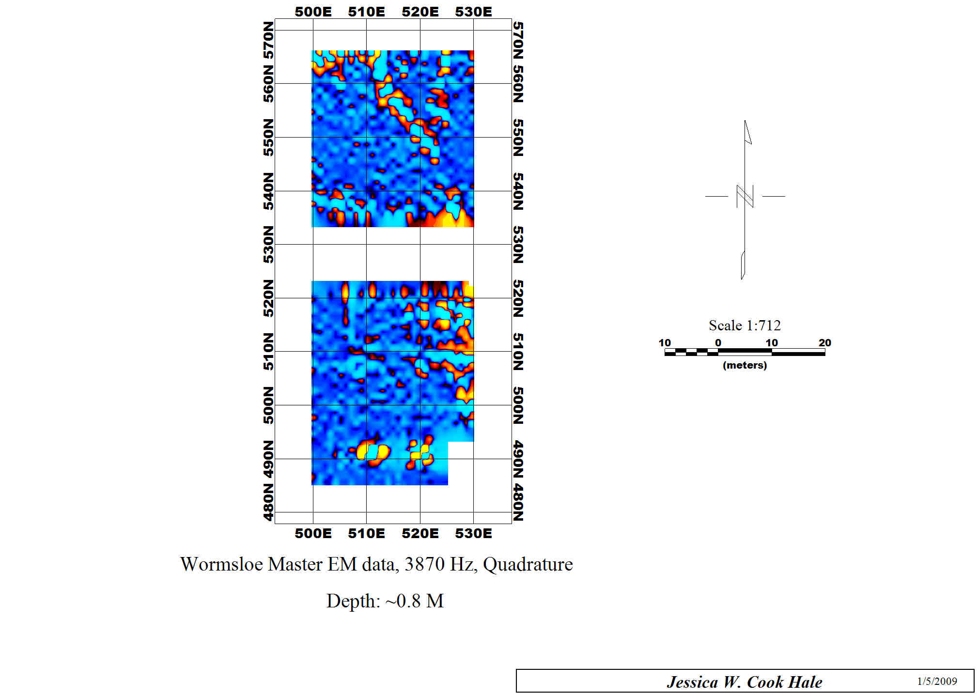
Figure 8: Master Grid EM data

Soil Probing and Pedestrian Survey
Ground probing was performed in the section of the survey area to the south of the burn pile as a way to ground truth certain anomalies seen in the GPR data. Initially, probing was done on a 5 meter spacing throughout the grid, and then narrowed to focus on an area immediately contiguous to the burn pile itself. This sector was probed on a 1 meter spacing. The probe was approximately 0.5 m in length, well within the target depth for the known features uncovered in spring of 2008.

Probing found that the area just to the south and east of the burn pile had significant debris, possibly composed of brick, in the subsurface at a depth of approximately 5 cm. The area extended nearly 10 meters from west to east, and 4 to 5 meters (approximately) from north to south. Data were plotted in Oasis MONTAJ for a plan view map (figure 9). One can easily see that there is an area of very dense debris just under the surface in the area spanning from approximately 510 N, 515 E, to 520 N, 530 E.
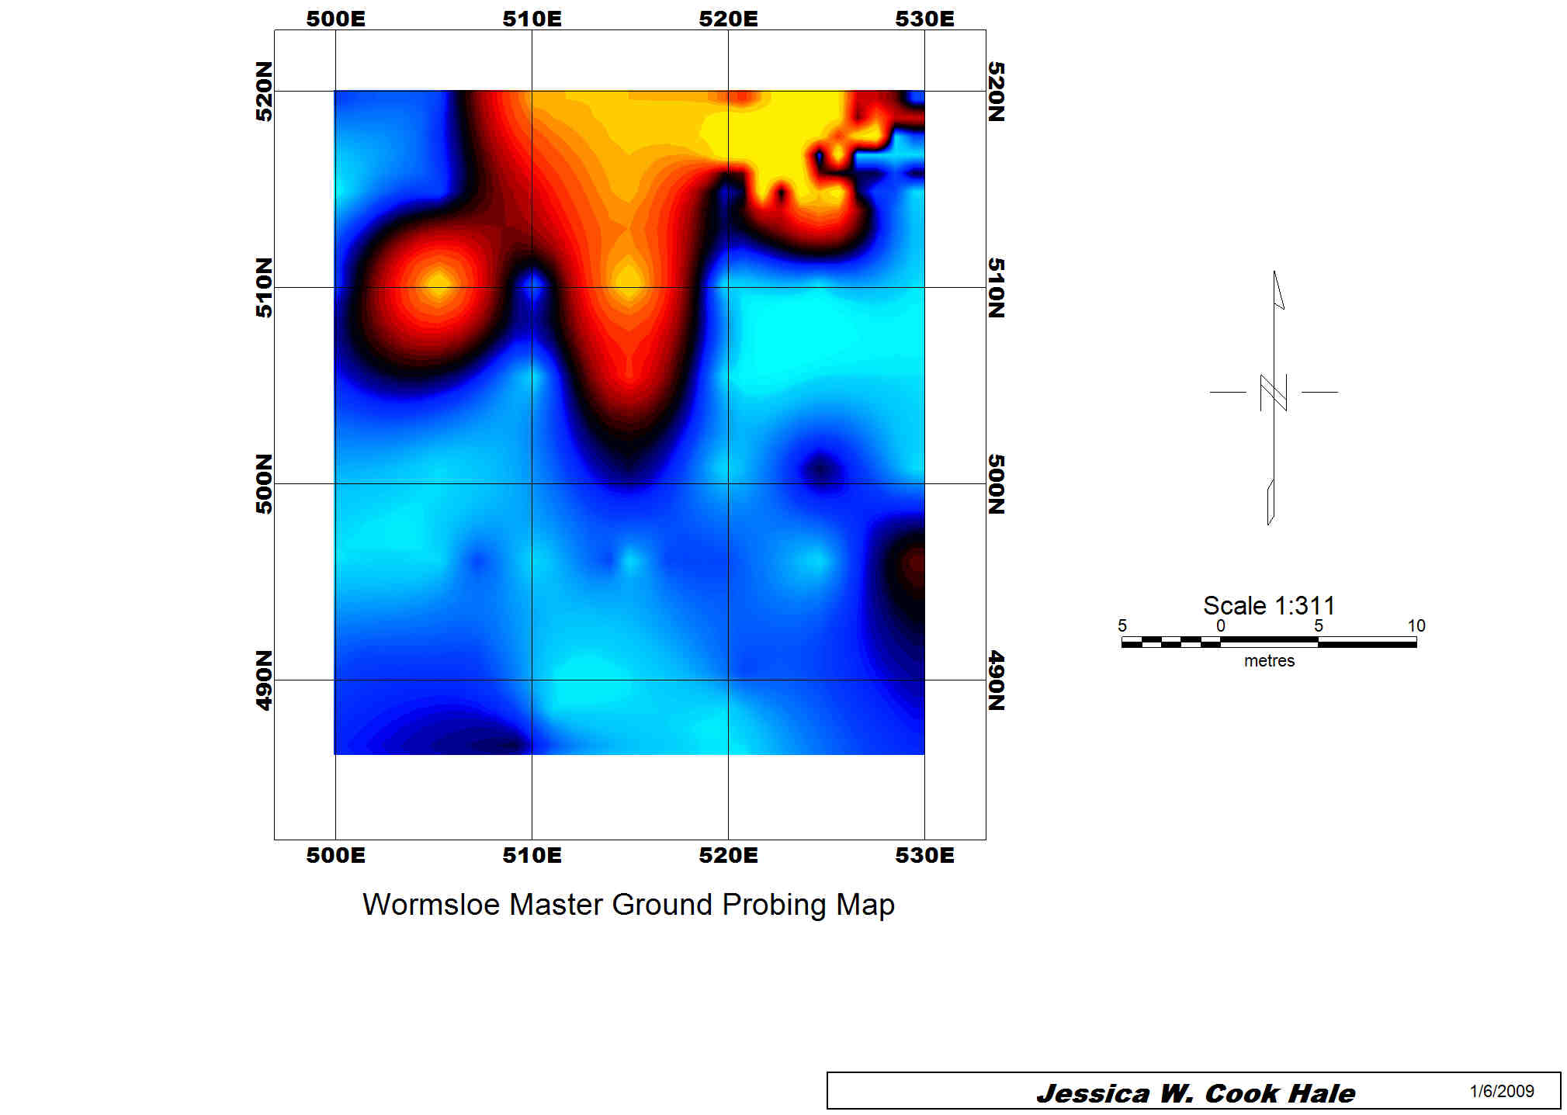
Figure 9: subsurface disturbance map, 485 N to 495 N, 500 E to 530 E

Pedestrian survey revealed some previously undetected surface scattered located south and east of the survey grid within areas densely covered by underbrush. Approximately 3 meters east of the grid there was noticeable building debris, consisting of bricks and mortar very similar in appearance to that which was excavated from Unit 4 in April of 2008. There were also two small glass items, probably bottles; one was green and the other brown. Finally, there was shell scatter east of the grid proximal to the building debris, and some shell scatter ~ 3 meters south of the grid.

Electrolysis
Initial electrolysis was performed on two iron nails and an iron strap. The oxidation (rust) was mostly removed in two days, albeit imperfectly. Further electrolysis efforts will focus on more thorough oxidation removal for significant artifacts, most likely by moderating the current to a lower intensity (Carlin et al., 2001). Additional anodes have been added in order to increase the number of artifacts that can be cleaned in one session, and this process will become an ongoing project in the field lab in order to assist in the final curation of the metal artifacts.

Discussion
To reiterate, while anomalies can not be automatically equated with known feature types, patterns can and do emerge that are suggestive of the possible nature of the subsurface features. In this case, it appears that a roughly rectilinear feature is present in the southern end of the new grid, supporting the decision to include more surface area in the new surveys. There are also intriguing anomalies in the eastern and northern portions of the grid.

The EM and GPR data show anomalies that correlate well to one another as well as to the ground probe data: Ground probing revealed the presence of a copious amount of brick squarely within the area showing these anomalies. It is clear that remains of some sort of structure lie very shallowly within the subsurface of this area of the field, spanning an area from around 500 N to 520 N, and 500 E to 530 E. The density of these remains is in marked contrast to the brick piers exposed during excavation in spring of 2008 (Structure 1) and probably constitute a different type of structural remains. They do lie at a similar depth to the excavated brick piers, however, and may date from roughly the same period.

Historical documentation
Discussions with Drew Swanson, Wormsloe Fellow from the History Department of the University of Georgia, revealed that within the family papers were various documents that recorded when structures were built on the plantation, and in some cases, where they were located in relation to the main house. In all cases, the type of building and the year in which it was built were recorded (Table 1).

Table 1: Complete list of Structures built during the 19th century at Wormsloe
Date | Type | Location
1829 | Plantation house
1829 | Servants’ house | 20’ x 15’, 95’ 6” due west of house
1829 | Stable | 20’ x 23’ stable, 134’ northwest of house
1849 | 3 slave houses
1849 | Another “servants’ hall”
1851 | Main house addition
1851 | Carriage house
1854 | 2 slave houses
1854 | Mill house (probably rice mill)
1854 | A shingled barn for peas
1854 | House piazza
1855 | Poultry house
1856 | Another stable
1856 | Overseer’s house
1856 | Overseer’s kitchen
1856 | Cotton gin house
1856 | Cotton storage house
1856 | 4 slave houses
1856 | Mule shed
1856 | Cow shed
1857 | “Plantation” stable
1857 | Cart house
1857 | Well house
1858 | Main house addition #2
1858 | Woodcutter’s shanty (northern end of plantation)
1859 | Mill house (perhaps a remodel of rice mill, or a sawmill)
1859 | Added wing on gin house
1860 | Cotton packing house
1874 | House on Long Island
1875 | New stable
1875 | New carriage house
1875 | New servants’ hall

In the cases where a building’s location was noted, it was possible to either include or eliminate that structure from a list of potential structures located within the survey area. Additionally, anything directly associated with the main house can be eliminated, as can the slave and/or servant houses, and structures for which photographs exist that show their locations, such as the well house (Table 2).

Table 2: Modified list of possible structures within survey area
Date | Type | Location
1851 | Carriage house
1854 | Mill house (probably rice mill)
1854 | A shingled barn for peas
1855 | Poultry house
1856 | Another stable
1856 | Cotton gin house
1856 | Cotton storage house
1856 | Mule shed
1856 | Cow shed
1857 | “Plantation” stable
1857 | Cart house
1859 | Mill house (perhaps a remodel of rice mill, or a sawmill)
1859 | Added wing on gin house
1860 | Cotton packing house
1875 | New stable
1875 | New carriage house

Two phases of construction can then be identified: pre-war construction during the decade immediately prior to the Civil War, and a less extensive phase during 1875, during the Reconstruction period. The pre-war construction is most likely related to unsuccessful efforts by George Wymberley Jones De Renne to make Wormsloe a profitable, working plantation (Bragg, 1999). During Reconstruction, only four buildings were added to the plantation, and three of these were possibly replacements or modifications of existing structures. During this period, Wormsloe was rented out to sharecroppers for a short period, but it was again, not a profitable venture (Bragg, 1999).

Examination of a map from 1897 showing improvements to the plantation clearly show three buildings in the survey area: One in the northwest corner, one in the southwest corner, and one in the northeast corner (see figures 1-4). If one assumes that Structure 1, partially excavated in April, 2008, is the building in the northwest corner of the field shown in the 1897 map, then the anomalies in this same area from the August GPR survey logically correlate to the building in the southwest corner of the grid.

However, if Structure 1 correlates instead to the building shown in the southwest corner of the survey area, then these anomalies represents something entirely different. This is a possibility: the working theory currently is that the shell feature was a walkway between structures, and the arms of the walkway lead south to Structure 1, and north to an as-yet unknown location, possible the northwest building.

It is also possible that the large collection of anomalies immediately south and slightly east of the burn pile are the remains of the rice mill, built in 1854. Photographs of the rice mill from the Historical American Building Survey (HABS) show a substantial structure of a size large enough to leave this sort of geophysical “footprint” in the subsurface after demolition. If one carefully examines the pattern of shadows in the photograph (figure 10), one can see that the building appears to cross the clearing from east to west. This is the same orientation as the rectilinear anomalies south of the burn pile. If these anomalies are indeed the remains of the rice mill, then it was placed just to the south and west of the current family cemetery.
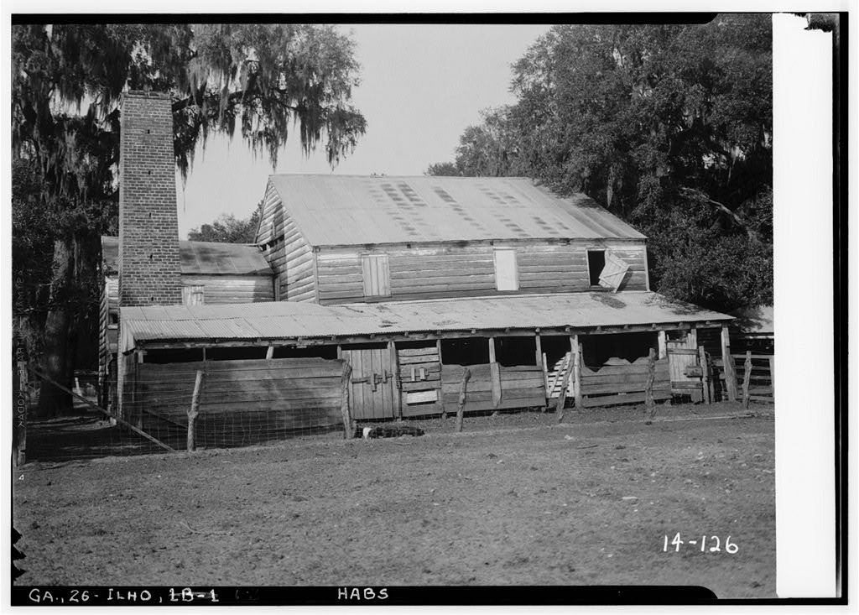
Figure 10: Rice Mill at Wormsloe
Historic American Buildings Survey Branan Sanders, Photographer March 1934

Conclusions

In summation, it is clear that the geophysical and geoarchaeological methods employed in this survey area have been successful in locating a number of anomalies that correlate well to potential archaeological features. It is true that one can not say with certainty what a specific anomaly may represent in terms of concrete archaeological features; however, when dealing with a site such as Wormsloe, it is often better to reconcile oneself with a modicum of uncertainty regarding the specifics, rather than employ potentially destructive methods in search of concrete remains that render only short term gains in overall knowledge of the site (Bevan, 1983).

The geophysical and geoarchaeological results presented here can not, and should not, exist within a vacuum of other data on the site. In fact, the results tend to remain opaque to the reader until evaluated and interpreted using historical and pictorial data. This multi-disciplinary approach has allowed us here a measure of comfortable speculation in terms of which buildings may have left these remains, and even from what years. Further work at Wormsloe will be focused on a continuation of these methods in other areas of the plantation in order to further the creation of a longitudinal database of geophysical and geoarchaeological data about the site, instead of a focus on only one site component. Spring of 2009 will see the beginning of new geophysical and geoarchaeological surveys slightly east of the first survey area; this area is one where the 1897 map shows a double row of slave cabins in a north-south axis. Only one now remains, and may not even date from the original construction period (1849, 1854, and 1856). It is hoped that these surveys will be as productive as the first round.

References

- Bevan, Bruce W., Electromagnetics for Mapping Buried Earth Features. Journal of Field Archaeology, Vol. 10, No. 1 (Spring, 1983), pp. 47-54
- Bragg, William Harris. De Renne: Three Generations of a Georgia Family. 1999, University of Georgia Press, Athens, Georgia, U.S.A.
- Carlin, Worth, Donald Keith and Juan Rodriguez “Less Is More: Measure of Chloride Removal Rate from Wrought Iron Artifacts during Electrolysis”Studies in Conservation, Vol. 46, No. 1 (2001), pp. 68-76
- Kvamme, Kenneth L. Geophysical Surveys as Landscape Archaeology. American Antiquity, Vol. 68, No. 3 (Jul., 2003), pp. 435-457
- Milsom, John. Field Geophysics, 2nd Edition. 1996, John Wiley and Sons, Chichester, New York, Brisbane, Toronto, Singapore.

